Game Design Document

Fill up the following document

1. Write the title of your project.

The tittle of my project it “ninja forest”.

1. What is the goal of the game?

The ninja has to complete the game and save the princess who is captured by a dianasaur.

1. Write a brief story of your game.

A princes of a great kingdom is captured by the enemy of the king of the kingdom. The enemy kings dragon has captured the princess. The king appoints his most amazing ninja to save his daughter. The ninja then starts its journy to save the princess. This is the part where the payer has to jump in in helping the ninja in saving the princess. In between the ninja get some cute creatures above it. If you are in trouble fighting with the dianasaur, it will help you there. You can also chat with the ninja if it gets confuse in going his way. You can see the map and direst the ninja which was it should goo. In betwwen you will of course get animals and obstacles are the ninja needs to fight with it to reach the princess. In the game the ninja has to collect some tools to save the princess in which the player has to help the ninja to get them. The tools can be any where, for example. On the mountains, under the sea or in the caves of lion. The ninja has to fight with all the animals he meets at the place of the tools. The ninja can also talk to the animal to get the tool and also fight with the animal. If the ninja wins the game, its well and good. If it does not winn the game, the ninja has to go back to the very recent check point and start the game their again. The ninja will get 5 lives in tottal but only 3 lives to fight with the animals. Of the ninja wins the game in one live only so, all the 2 lives of the ninja will be added to the next level / to fight with the next animal. And also, the ninja has to collect some coins and the jewlary which the princess has thrown on the way to the which temple. The enemy king might ask for the coins and gold from the ninja. All the best and lets save the princess.

1. Which are the playing characters of this game?

* Playing characters are the ones who respond to the user based on the input from the user.
* Cars, monkeys, dinos, wizards, etc., are the playing characters in the game.

|  |  |  |
| --- | --- | --- |
| Number | Character Name | What can this character do? |
| 1 | The ninja | Runner player |
| 2 | evil | When player toucher it, it kills the player. |
| 3 | coins | When the player touches them, they are distroyed and the player gets points. |
| 4 |  |  |
| 5 |  |  |
| 6 |  |  |
| 7 |  |  |
| 8 |  |  |

1. Which are the Non-Playing Characters of this game?

* Non-Playing characters are the ones that don't have an action or behavior when the user interacts with the game.
* Hurdles, stones, bananas, coins, etc., are non-playing characters in the game.

|  |  |  |
| --- | --- | --- |
| Number | Character Name | What can this character do? |
| 1 | Coins | Give points |
| 2 | The pink bird | Only fly in the air |
| 3 |  |  |
| 4 |  |  |
| 5 |  |  |
| 6 |  |  |
| 7 |  |  |
| 8 |  |  |

Draw your imagination of this game. What does this game look like?

* Draw the game either on your computer or on paper.
* Add images of the game scenes to show each of the playing and non-playing characters at least once.

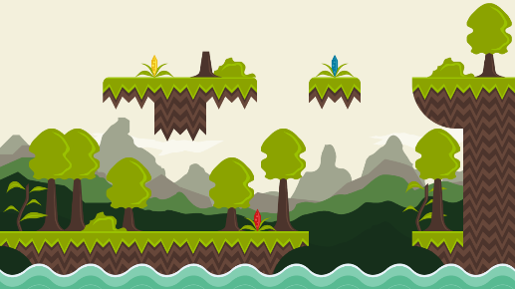 the jungle setting.

How do you plan to make your game engaging?

It is engaging because it has a lot of characters and a lot of chalange sand a lot of check poins and advantages to the player so that the player stays in close to the game. It is fun because I have desigined it and also the animations which I have but in it. I actually can relate to some of the people and the child hood and the treasure hunt game and the princess and princess game we used to play when were kids. It brings back the childhood memories.